# Preliminary Carbon Emissions Report for South African Health Facilities in Carbon Mitigation Project for High Horizons

8 December 2023

## Compiled by Otsile Lekabe, Khudu Segane and Craig Parker. Data collected by carbon monitors

## Introduction

This report presents a preliminary analysis of the first four months of carbon emissions data, collected from July 1st, 2023, to October 31st, 2023, from three distinct South African health facilities: Laudium Community Health Centre, Stanza Bopape Community Health Centre, and Mamelodi Regional Hospital. These facilities are part of the Carbon Mitigation Project for High Horizons, and the data reflects a range of emission sources across Scope 1, Scope 2, and Scope 3 categories, offering initial insights into their environmental impacts.

Scope 1, 2, and 3 emissions are crucial concepts in the context of carbon emissions. Scope 1 emissions refer to direct greenhouse gas emissions from sources owned or controlled by healthcare facilities, such as onsite fuel combustion for heating and power generation, as well as emissions from owned or leased vehicles. Scope 2 emissions, conversely, encompass indirect emissions from generating purchased electricity, heat, or steam that healthcare facilities consume. Lastly, Scope 3 emissions include all other indirect emissions due to the healthcare facilities' activities but from sources not owned or controlled by the facilities, such as employee commuting, waste generation, and supply chain activities. Understanding and analysing emissions across these three scopes is essential for a comprehensive assessment of the environmental impact of healthcare facilities, as it allows for a holistic view of their carbon footprint and identifies opportunities for mitigation and reduction strategies (IPCC, 2006; WRI, 2011).

## Background about facilities

Laudium CHC, located in Pretoria West, serves approximately 245,387 individuals and provides comprehensive health services, including emergency care and primary health services. Stanza Bopape CHC, situated east of Tshwane, covers an area of 49.19 km² and caters to a population of 261,989, offering critical healthcare services, including support for gender-based violence victims and antiretroviral therapy adherence clubs. Mamelodi Regional Hospital functions as a regional hospital and a referral site, serving a population of 334,577 with a range of clinical specialities.

It is crucial to differentiate the scope of services and operational scales when comparing these facilities. As a higher-level referral centre with more extensive services, Mamelodi Regional Hospital differs from the community health centres of Laudium and Stanza Bopape, which are more aligned in the scale and scope of services they provide.

## Data Summary

* **Laudium Community Health Centre** has recorded **243,632.31 Kg of CO₂ emissions** in the first four months of data collection. Significant contributions to this total come from grid electricity (62,870.43 Kg), liquid fuel (53,138.75 Kg), and inhalers (42,687.37 Kg).
* **Stanza Bopape Community Health Centre** reported **293,716.14 Kg of CO₂ emissions** in the initial four months. The significant emissions sources here include vehicle fuel (200,305.58 Kg), inhalers (46,570.09 Kg), and liquid fuel (15,440.44 Kg).
* **Mamelodi Regional Hospital** shows a total emission of **651,154.88 Kg of CO₂** for the same period, with notable emissions from vehicle fuel (72,673.53 Kg), business travel (184,769.61 Kg), and inhalers (34,074.90 Kg).

These figures, reflecting the first four months of the Carbon Mitigation Project for HIGH Horizons, provide a crucial baseline for understanding and addressing the carbon footprint of healthcare operations within the region.

## Observations

* The data showcases significant variability in emission sources and volumes across the facilities, underscoring their unique operational characteristics. For Stanza Bopape CHC, Scope 1 emissions from liquid fuel were notably lower in October due to decreased power cuts, potentially influenced by the Rugby World Cup. Diesel usage is on a request basis, correlating with the frequency of power cuts, which were more prevalent during the stage 6 load-shedding events in August and September.
* Vehicle fuel emissions were exceptionally high when Stanza Bopape CHC undertook errands for other facilities, such as Stanza 1 Clinic. This variance in fuel usage reflects the intermittent nature of these errands and the reduced travel when fewer cars are on the road. We are reaching out to the fleet manager to check if any data quality issues exist.
* Business travel emissions data, recorded on the 'Travel-other' sheet, initially presented challenges in obtaining detailed information from the staff. However, as employee participation increased over time, the data collection for daily trips from home to work became more reliable, enhancing the accuracy of the emissions calculation.
* For inhalers, a fluctuating dispensation pattern was observed, attributed to the three-month medication supply given to patients and the seasonal demand spikes, such as during the cold and flu season.
* Mamelodi Regional Hospital, operating from July 1st to October 31st, 2023, is a regional and referral hospital for Stanza Bopape and Laudium CHC. Its Scope 3 emissions are markedly high due to extensive business travel necessitated by its broader range of services, such as theatre operations. The hospital's vehicle fuel usage varied, with higher consumption in July and a notable decrease in subsequent months due to the loss of vehicles to hijacking and breakdowns. Inhaler usage reflected the influence of seasonal variations, with prescriptions covering three-month periods.
* These observations indicate that while there are commonalities in emission sources across the facilities, the reasons behind them differ, from operational requirements to seasonal health demands. The report also acknowledges data gaps, highlighted by "n/a" entries, necessitating more robust data collection and reporting mechanisms for a comprehensive emissions profile

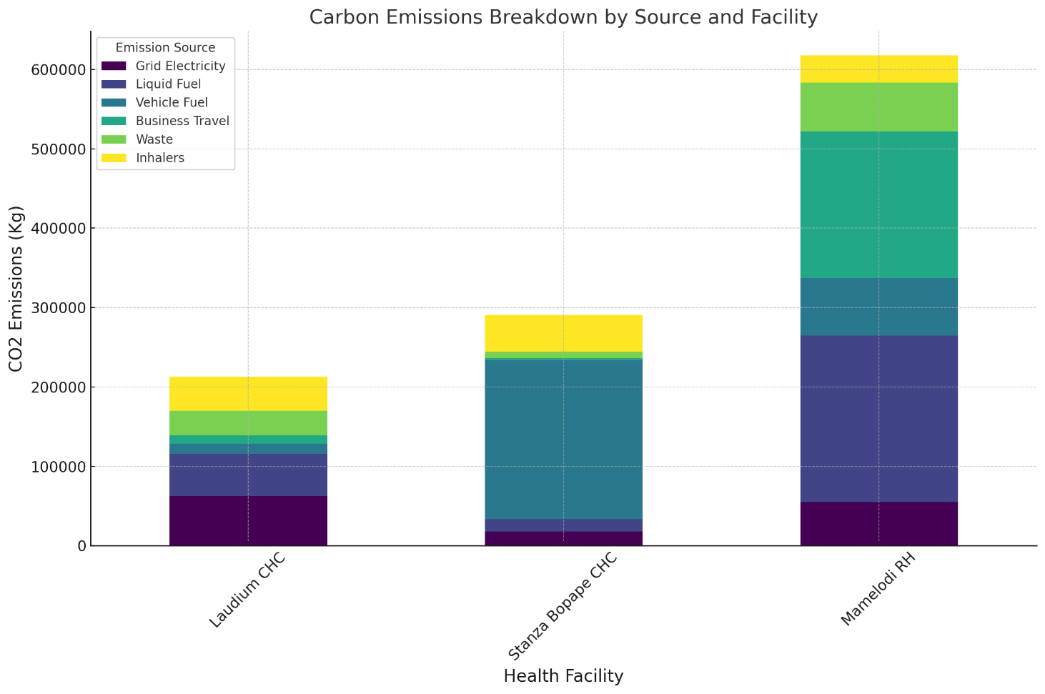

Figure 1: breakdown of carbon emissions by source for each health facility.

Figure 1 presents a breakdown of each health facility's carbon emissions source. The emissions are categorised as follows:

* Grid Electricity: Emissions from the electricity the healthcare facility draws from the power grid.
* Liquid Fuel: Emissions from the combustion of diesel fuel, typically used in backup generators during power outages.
* Vehicle Fuel: Emissions from fuel consumed by healthcare facility vehicles, such as ambulances and staff vehicles.
* Business Travel: Emissions attributed to the travel activities for business purposes, including staff travel between different sites or to attend conferences and meetings.
* Waste: Emissions generated from healthcare operations' disposal and treatment of waste products.
* Inhalers: Emissions associated with producing and disposing of respiratory inhalers used in healthcare facilities.
* These categories collectively represent the comprehensive carbon footprint of the healthcare facilities, reflecting the diversity and scope of operations within each one.

## Consolidated Carbon Emissions Data for South African Health Facilities

|  |  |  |  |  |
| --- | --- | --- | --- | --- |
| Variable | Laudium CHC (Kg CO₂) | Stanza Bopape CHC (Kg CO₂) | Mamelodi RH (Kg CO₂) | Total (Kg CO₂) |
| Scope 1 |  |  |  |  |
| Grid Electricity | **62,870.43** | **17,874.98** | **54,755.60** | **135,301.01** |
| Liquid Fuel | **53,138.75** | **15,440.44** | **209,651.32** | **278,230.51** |
| Vehicle Fuel | **12,372.17** | **200,305.58** | **72,673.53** | **285,351.28** |
| Anaesthetic Gases | **-** | **-** | **30,188.80** | **30,188.80** |
| Refrigerants | **22,986.96** | **7,787.34** | **91,598.96** | **122,373.26** |
| Scope 3 |  |  |  |  |
| Vehicle Distance | **7,999.16** | **9,688.97** | **10,722.92** | **28,410.05** |
| Business Travel | **10,463.96** | **3,019.29** | **184,769.61** | **198,252.86** |
| Waste | **31,113.51** | **7,604.12** | **61,419.24** | **100,136.87** |
| Inhalers | **42,687.37** | **46,570.09** | **34,074.90** | **123,332.36** |
| Total Kg CO₂ | **243,632.31** | **293,716.14** | **651,154.88** | **1,222,366.00** |

**CHC**: Community Health Centre  
**RH**: Regional Hospital

## Initial Trends in the Data

Figure 3: Quarterly Emissions Trends at South African Health Facilities (July - October 2023)

## Initial Observations and Highlights:

* The fluctuations in the emissions trends graphs for the three health centers can be explained by operational factors specific to each facility:
* Laudium CHC: The rise in liquid fuel emissions corresponds with the use of a large diesel generator, with usage under 2000 liters despite the generator's capacity, suggesting efficient usage during load shedding. Increases in inhaler usage could be due to heightened demand during the flu season or enhanced data collection methods.
* Mamelodi RH: The consistent liquid fuel usage likely indicates stable diesel generator use, integral to its broader service offering, including theatre operations. The increased business travel emissions may reflect more travel activities or improved data capture.
* Stanza Bopape CHC: The sharp increase in vehicle fuel emissions in October is likely due to undertaking more errands for other facilities during that period. The decrease in grid electricity emissions in October could be due to fewer power outages, potentially due to reduced load-shedding during the Rugby World Cup.
* These explanations incorporate the operational context provided, giving insight into the reasons behind the observed emissions data fluctuations.

The fluctuations in the emissions data across the health facilities reflect operational activities and highlight the initial data collection challenges. For instance, Stanza Bopape CHC's erratic vehicle fuel emissions could be due to both the variable nature of the errands it performs and the maturation of data recording methods. Similarly, the rising trend in business travel emissions across the facilities might indicate increased travel activities or progressively improved data accuracy. Early difficulties in gathering accurate travel data were mitigated as more staff participated in reporting, contributing to a more reliable dataset over the observed months. These factors, combined with operational specifics, such as the use of generators during power cuts at Laudium CHC and the consistent operations at Mamelodi Regional Hospital, provide a comprehensive understanding of the emissions trends.

|  |  |  |  |  |  |  |
| --- | --- | --- | --- | --- | --- | --- |
| **Laudium Community Health Centre** | |  |  |  |  | **Total Q 3 emissions** |
|  | **Variable** | **July** | **August** | **September** | **October** | **(Kg CO₂)** |
| Scope 1 | Grid Electricity | 21,450.91 | 17,209.44 | 8,171.77 | 15,838.31 | **62,870.43** |
| Scope 1 | Liquid fuel | 4,979.22 | 12,120.47 | 16,711.83 | 19,327.23 | **53,138.75** |
| Scope 1 | Vehicle Fuel | 4,274.63 | 1,430.69 | 1,758.63 | 4,908.22 | **12,372.17** |
| Scope 3 | Vehicle Distance | 1,687.23 | 1,967.92 | 1,978.38 | 1,965.63 | **7,999.16** |
| Scope 3 | Business travel | 167.46 | 246.78 | 5,024.86 | 5,024.86 | **10,463.96** |
| Scope 1 | Anaesthetic gases | - | - | - | - | **-** |
| Scope 1 | Refrigerants | 5,746.74 | 5,746.74 | 5,746.74 | 5,746.74 | **22,986.96** |
| Scope 3 | Waste | 8,479.37 | 7,969.99 | 4,454.26 | 10,209.89 | **31,113.51** |
| Scope 3 | Inhalers | 7,921.05 | 5,825.54 | 10,227.74 | 18,713.04 | **42,687.37** |
|  | **Total Kg CO₂** | **54,706.61** | **40,523.09** | **41,681.93** | **71,241.44** | **243.632.31** |

* Decreased Scope 1 emissions in September are credited to reduced vehicle fuel usage as one of the vans was being repaired in August and September.
* September and October witnessed a rise in Scope 3 emissions due to increased inhaler requests during winter.
* High levels of blowing sand, likely from the nearby mine, are suspected to contribute to increased emissions.

|  |  |  |  |  |  |  |
| --- | --- | --- | --- | --- | --- | --- |
| **Mamelodi Regional Hospital** | |  |  |  |  | **Total Q 3 emissions** |
|  | **Variable** | **July** | **August** | **September** | **October** | **(Kg CO₂)** |
| Scope 1 | Grid Electricity | 18,252.13 | 9,125.67 | 9,125.67 | 18,252.13 | **54,755.60** |
| Scope 1 | Liquid fuel | 52,412.83 | 52,412.83 | 52,412.83 | 52,412.83 | **209,651.32** |
| Scope 1 | Vehicle Fuel | 65,600.31 | 3,105.17 | 1,868.75 | 2,099.30 | **72,673.53** |
| Scope 3 | Vehicle Distance | 2,462.29 | 2,451.14 | 3,614.05 | 2,195.44 | **10,722.92** |
| Scope 3 | Business travel | 60,761.32 | 60,761.32 | 3,038.07 | 60,208.90 | **184,769.61** |
| Scope 1 | Anaesthetic gases | 5,660.40 | 5,660.40 | 7,547.20 | 11,320.80 | **30,188.80** |
| Scope 1 | Refrigerants | 22,899.74 | 22,899.74 | 22,899.74 | 22,899.74 | **91,598.96** |
| Scope 3 | Waste | 15,905.82 | 15,041.99 | 15,515.42 | 14,956.01 | **61,419.24** |
| Scope 3 | Inhalers | 1,873.84 | 14,247.59 | 14,871.93 | 3,081.54 | **34,074.90** |
|  | **Total Kg CO₂** | **245,828.68** | **185,705.85** | **130,893.66** | **187,426.69** | **651,154.88** |

* The increase in Scope 3 emissions in September and October is due to increased inhaler requests during the winter months.
* The facility's proximity to a mine is likely contributing to the high levels of blowing sand, which can lead to increased carbon emissions.

|  |  |  |  |  |  |  |
| --- | --- | --- | --- | --- | --- | --- |
| **Stanza Bopape Community Health Centre** | |  |  |  |  | **Total Q 3 emissions** |
|  | **Variable** | **July** | **August** | **September** | **October** | **(Kg CO₂)** |
| Scope 1 | Grid Electricity | 3,227.85 | 4,100.82 | 5,379.23 | 5,167.08 | **17,874.98** |
| Scope 1 | Liquid fuel | 2,206.21 | 6,551.60 | 5,896.44 | 786.19 | **15,440.44** |
| Scope 1 | Vehicle Fuel | 38,896.46 | 38,137.11 | 994.61 | 122,277.40 | **200,305.58** |
| Scope 3 | Vehicle Distance | 2,701.34 | 1,262.99 | 2,667.84 | 3,056.80 | **9,688.97** |
| Scope 3 | Business travel | 34.49 | 34.56 | 1,660.77 | 1,289.47 | **3,019.29** |
| Scope 1 | Anaesthetic gases | - | - | - | - | **-** |
| Scope 1 | Refrigerants | 1,937.92 | 1,937.92 | 1,937.92 | 1,973.58 | **7,787.34** |
| Scope 3 | Waste | 3,852.19 | 1,978.02 | 1,196.46 | 5,77.45 | **7,604.12** |
| Scope 3 | Inhalers | 22,115.75 | 4,220.70 | 10,566.54 | 9,667.10 | **46,570.09** |
|  | **Total Kg CO₂** | **74,972.21** | **58,223.72** | **30,299.81** | **144,795.07** | **293,716.14** |

* Fewer power cuts: Compared to other months, October saw a significant decrease in power outages, resulting in lower liquid fuel usage.
* Vehicle fuel increase: Despite the decrease in power cuts, vehicle fuel consumption jumped in October. The fleet manager has been requested to provide clarification on this discrepancy.

## Recommendations for South African Health Facilities

Based on the analysis of the carbon emissions data from Laudium Community Health Centre, Stanza Bopape Community Health Centre, and Mamelodi Regional Hospital, the following recommendations are proposed to enhance carbon mitigation efforts and data accuracy:

1. Refine Data Collection Processes: Streamline and enhance the data collection protocols to improve consistency and accuracy, incorporating staff training and standardized templates. Collaboration with district authorities for training on data collection is crucial.
2. Target Key Emission Sources: Focus on reducing emissions from primary sources such as liquid fuel and grid electricity by adopting alternative energy sources and efficient practices, with technical assistance from experts like Carbomica for specific mitigation strategies.
3. Optimize Vehicle Fuel Usage: Address the variable vehicle fuel emissions at Stanza Bopape by investigating the causes and implementing measures such as maintenance, route optimization, and promotion of fuel-efficient driving.
4. Streamline Business Travel: For the high emissions from business travel at Mamelodi, encourage the use of teleconferencing and streamline travel schedules to minimize unnecessary trips.
5. Adopt Green Technologies: Invest in green technologies to reduce reliance on conventional energy, particularly to lower grid electricity emissions, including solar panels and energy-efficient appliances.
6. Enhance Waste Management: Establish robust waste management and recycling initiatives to reduce waste-related emissions, looking into waste reduction, recycling, and waste-to-energy solutions.
7. Foster Community Engagement: Involve local communities in carbon mitigation efforts through educational programs and participation in sustainability initiatives.
8. Implement Monitoring and Reporting: Set up regular emissions monitoring and reporting to track mitigation progress and refine strategies as needed.
9. Benchmark and Share Best Practices: Engage in benchmarking with other healthcare facilities and sectors to share best practices and identify further improvement opportunities.

Implementing these recommendations will not only contribute to reducing the carbon footprint of these health facilities but also set a precedent for environmental responsibility in the healthcare sector in South Africa.

## Conclusion

The preliminary analysis of carbon emissions data from Laudium CHC, Stanza Bopape CHC, and Mamelodi RH for the Carbon Mitigation Project for High Horizons has provided a snapshot of their carbon footprint from July to October 2023. Each facility exhibits distinct emission profiles: Laudium CHC with significant emissions from grid electricity and liquid fuels, Mamelodi RH with consistent liquid fuel emissions, and Stanza Bopape CHC with variable vehicle fuel emissions. This variability may point to specific operational needs and the maturation of data collection practices. As data collection standardizes, we anticipate future reports will yield more definitive insights for targeted carbon mitigation actions. This phase underscores the essential role of robust data collection in environmental strategy formulation for healthcare facilities.

## References:

1. Intergovernmental Panel on Climate Change (IPCC). (2006). IPCC Guidelines for National Greenhouse Gas Inventories, Volume 1: General Guidance and Reporting. Retrieved from https://www.ipcc-nggip.iges.or.jp/public/2006gl/index.html World Resources Institute (WRI). (2011).
2. The Greenhouse Gas Protocol: A Corporate Accounting and Reporting Standard (Revised Edition). Retrieved from https://ghgprotocol.org/standards/overview